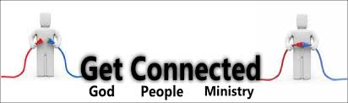
At GREATER LIFE we want to make it simple for you to not only connect with God, but connect with others. Our church is designed to help all ages take the next step In their Christian walk by linking them with their best fit group.

God made us to live life in the context of community. We're designed to laugh together, grow together and serve together. It makes us better people and we achieve more together. Here are a few simple ways to get connected to what God is doing in and through us.
1) Like us on facebook.. GREATER LIFE BAPTIST CHURCH
2) Check out our website to receive updates
3) Starting Point. If you really want to take action, get involved and add your gifts and talents to this community of people who are trying to make a difference in the world, there is essentially one basic way - be a part of a Starting Point group. This is our starting point at GREATER LIFE, At the end of this 10 week group study, you'll be given options of joining an ongoing small group and/or service team.
4) The Big 3. Being a part of Greater Life involves three main things: Attending on Sundays, Being a part of a group and Serving on a ministry team. To really grow in your faith and flourish in how God has made you to bless the world, if indeed you call GREATER LIFE your spiritual home, then doing all three is crucial.

